(Title page)

* **SUSTAINABLE WASTE**
* **LA9_C3**
* **Ryan Wells – 101964547**
* **Syed Omair Maqdoom Mohiuddin – 102863768**
* **Monday 4:30 pm to 6:30 pm**
* **2021 Semester 1**
* **Word count:**

**1.Introduc**

Contents

**[1.Introduction](#_Toc74102944)** [4](#_Toc74102944)

[1.1 Background and Motivation 4](#_Toc74102944)

[1.2 Visualisation Purpose 4](#_Toc74102944)

[1.2.1 Questions answered by visualisation 4](#_Toc74102944)

[1.2.2 Possible benefits of completed visualisation 4](#_Toc74102944)

[1.3 Project Schedule 4](#_Toc74102944)

**[2.Data](#_Toc74102944)** [5](#_Toc74102944)

[2.1 Data Source (Proposal) 5](#_Toc74102944)

[2.1 Data Source (Final) 5](#_Toc74102944)

[2.2 Data Processing (Proposal) 7](#_Toc74102944)

[2.2 Data Processing (Progress) 8](#_Toc74102944)

[2.2 Data Processing (Final) 9](#_Toc74102944)

**[3.Requirements](#_Toc74102944)** [9](#_Toc74102944)

[3.1 Must-Have features (Proposal) 9](#_Toc74102944)

[3.1 Must-Have Features (Final) 9](#_Toc74102944)

[3.2 Optional Features (Proposal) 9](#_Toc74102944)

[3.2 Optional Features (Final) 9](#_Toc74102944)

**[4.Visualisation Design (Proposal)](#_Toc74102944)** [10](#_Toc74102944)

[4.1 Choropleth map 10](#_Toc74102944)

[4.2 Pie chart 10](#_Toc74102944)

[4.3 Scatter plot 11](#_Toc74102944)

**[4.Visualisation Design (Progress)](#_Toc74102944)** [11](#_Toc74102944)

[4.1 Choropleth 11](#_Toc74102944)

[4.2 Pie Chart 13](#_Toc74102944)

[4.3 Scatter Plot 14](#_Toc74102944)

**[4.Visualisation Design (Final)](#_Toc74102944)** [16](#_Toc74102944)

[4.1 Choropleth 16](#_Toc74102944)

[4.2 Pie Chart 16](#_Toc74102944)

[4.3 Scatter Plot 17](#_Toc74102944)

**[5.Validation](#_Toc74102944)** [18](#_Toc74102944)

[5.1 Informed Consent 18](#_Toc74102944)

[5.2 Pre-Study Questionnaire 19](#_Toc74102944)

[5.3 Evaluation Tasks 19](#_Toc74102944)

[5.4 Post-Study Questionnaire – 1 20](#_Toc74102944)

[5.5 Post-Study Questionnaire – 2 21](#_Toc74102944)

[5.6 Responses and Results 21](#_Toc74102944)

[5.7 Changes Required 21](#_Toc74102944)

**[6.Conclusion](#_Toc74102944)** [21](#_Toc74102944)

**[References](#_Toc74102944)** [22](#_Toc74102944)

**tion** 4

1.1 Background and Motivation 4

1.2 Visualisation Purpose 4

1.2.1 Questions answered by visualisation 4

1.2.2 Possible benefits of completed visualisation 4

1.3 Project Schedule 4

**2.Data** 5

2.1 Data Source (Proposal) 5

2.1 Data Source (Final) 5

2.2 Data Processing (Proposal) 7

2.2 Data Processing (Progress) 8

2.2 Data Processing (Final) 9

**3.Requirements** 9

3.1 Must-Have features (Proposal) 9

3.1 Must-Have Features (Final) 9

3.2 Optional Features (Proposal) 9

3.2 Optional Features (Final) 9

**4.Visualisation Design (Proposal)** 10

4.1 Choropleth map 10

4.2 Pie chart 10

4.3 Scatter plot 11

**4.Visualisation Design (Progress)** 11

4.1 Choropleth 11

4.2 Pie Chart 13

4.3 Scatter Plot 14

**4.Visualisation Design (Final)** 16

4.1 Choropleth 16

4.2 Pie Chart 16

4.3 Scatter Plot 17

**5.Validation** 18

5.1 Informed Consent 18

5.2 Pre-Study Questionnaire 19

5.3 Evaluation Tasks 19

5.4 Post-Study Questionnaire – 1 20

5.5 Post-Study Questionnaire – 2 21

5.6 Responses and Results 21

5.7 Changes Required 21

**6.Conclusion** 21

**References** 22

# **1.Introduction**

## 1.1 Background and Motivation

* People that are 16-30 years old who are interested in reducing the amount of waste that they are producing.

what we mean by waste - items that are sent to landfill by municipalities

* + - breakdown based on country
    - socioeconomic status of countries
    - different categories of waste

## 1.2 Visualisation Purpose

### 1.2.1 Questions answered by visualisation

* how much waste different countries produce?
* how well different countries handle waste management?
* the amount of waste produced that could be better utilised.
* Compare GDP and the amount of waste generated country wise?
* Countries can compare the amount of waste they generate with other countries and try to take required steps to reduce the generated waste.

### 1.2.2 Possible benefits of completed visualisation

* influence purchasing habits
* Influences living (consuming) habits
* Influence global policies relating to waste (waste is a global issue, not just for Australia/Victoria and developing nations may need assistance creating policy as they become more developed)
* Countries can follow policies/plans used by co-countries whose GDP is high and waste generation is low.
* Countries can tailor their policies according to the composition of their waste. For example, America has a high proportion of paper and cardboard entering landfill, so policies could be created to increase the amount of paper and cardboard being recycled.

## 1.3 Project Schedule

|  |  |
| --- | --- |
| **Week** | **Work to be completed** |
| Week 1 | Planning for different visualisations and searching for dataset. Interacting with new group members and discussing ideas. |
| Week 2 | Searching for data related to the project topic (sustainability: Waste). Discussing about the gathered data and choosing best data for the project. |
| Week 3 | Referring to some visualisations for some ideas and preparing sketches (prototyping). Start making report on the project (Process Book). |
| Week 4 | Preparing paper prototype and discussing views and gathering feedback from group. Updating process book. |
| Week 5 | Updating the prototypes as per the feedback from tutor and adding some more designs to visualisations. Updating process book. |
| Week 6 | Using online tools to prepare high fidelity prototypes for the project. Start the programming part of the project. Distribution of work among the group members. Updating process book. |
| Week 7 | Individual member should start their given part of programming and any issues discuss in group meetings. Updating the process book with information regarding the website (Visualisations). |
| Week 8 | Get ready with programming part of visualisations, not with all the functionality but with at least minimum requirements. Updating process book. |
| Week 9 | Explain the functionality, design and features in the visualisation and ask for suggestions in visualisations. |
| Week 10 | Working on suggestions and implementing required features (essential and optional). |
| Week 11 | Combining all the visualisation together in a form of a website and adding descriptions (features) for each visualisation. Updating process book. |
| Week 12 | Making the website attractive using CSS designs. Preparing for User Evaluation. Preparing informed consent, questionannire for evaluation process and planning the required tasks for evaluation. Updating the process book. |
| Week 13 | Conducting User Evaluation and validating the website, noting down their responses and making the required changes. Finalising the Process book.Once group is satisfied with the work, submitting the work. |

# **2.Data**

## 2.1 Data Source (Proposal)

## 2.1 Data Source (Final)

Data used is the “What a Waste Global Database” published by The World Bank, accessible from <https://datacatalog.worldbank.org/dataset/what-waste-global-database>.

This data set contains a collated set of statistics related to waste production for most countries around the world. It was stored in a tabular form in a CSV file.

* Type of data set – table
* Attributes – categorical and continuous (country names, iso3c, region id, income id, other information columns, where data is measured), ratio/quantitative (rest?)
* Data not included – excluded the attributes which are not realted to visualisations (like population, collection of waste from different areas, its percentage, where is the data measured from and other attributes)

|  |  |  |
| --- | --- | --- |
| **Attribute** | **Description** | **Type** |
| **iso3c** | This field is for the country code, it is a unique 3 letter code which distinguishes each country in the data. | Categorical (Text) |
| **Country_name** | This filed consist of the name of the country in the data. | Categorical (Text) |
| **gdp** | This field consist of the Gross Domestic Product (GDP) of a country. IT is different for each country. | Continuous (Number) |
| **composition_food_organic_waste_percent** | This field contains the composition of food and organic waste to the whole waste of the country. | Continuous (Number) |
| **composition_glass_percent** | This field contains the composition of waste generated from glass sector and tells its contribution to whole waste of the country. | Continuous (Number) |
| **composition_metal_percent** | This field contains the composition of waste generated from metal sector and tells its contribution to whole waste of the country. | Continuous (Number) |
| **composition_other_percent** | This field contains the composition of waste generated from other sectors. | Continuous (Number) |
| **composition_paper_cardboard_percent** | This field contains the composition of waste generated from paper and cardboard waste and its contribution to the whole waste of the country. | Continuous (Number) |
| **composition_plastic_percent** | This field contains the composition of plastic waste and its contribution towards the whole waste of the country. | Continuous (Number) |
| **composition_rubber_leather_percent** | This field contains the composition of rubber and leather waste and its contribution towards whole waste of the country. | Continuous (Number) |
| **composition_wood_percent** | This field contains the composition of waste generated from wood and its contribution to the whole waste of the country. | Continuous (Number) |
| **composition_yard_garden_green_waste_percent** | This field contains the composition of waste generated from green waste (yard and garden) and its contribution towards the whole waste of the country. | Continuous (Number) |
| **total_msw_total_msw_generated_tons_year** | This fields contains the whole waste generated by country in a year. It tells the total municipal solid waste generated tons per year. | Continuous (Number) |

## 2.2 Data Processing (Proposal)

* No extensive data processing required.
* Removed lines with no values in the columns related to visualisations and removed columns not needed for visualisations – done using the python pandas library. (Make finding the data easier in browser console and reduce file size)

## 2.2 Data Processing (Progress)

The collected dataset requires minimal amount of Processing to allow the data to be displayed accurately in the visualisations, because it was structured data in the form of a CSV file. Using Pandas Libriray from Python to process the data. Removed lines with empty data in the colums related to the visualisation

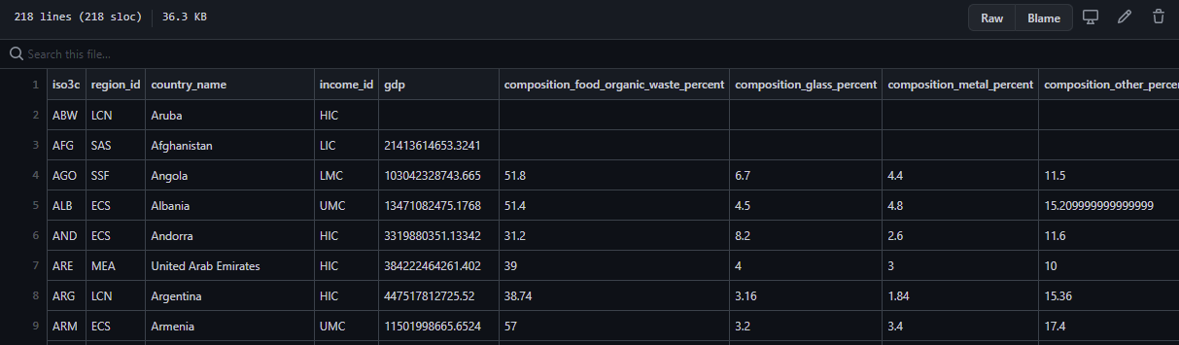

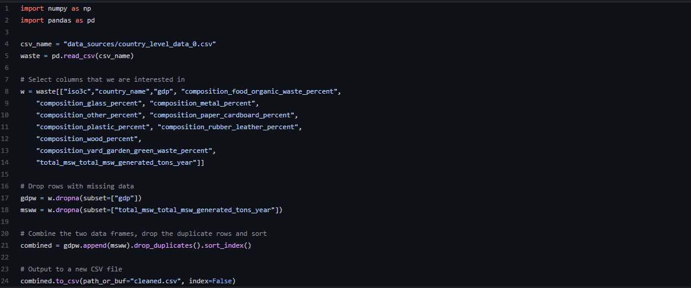

## 2.2 Data Processing (Final)

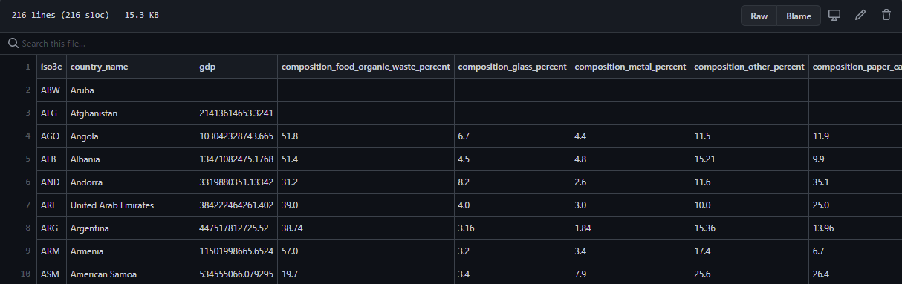

Figure 1: Processed Data after all the processing

# **3.Requirements**

These are features without which you would consider your project to be a failure. Were you able to deliver all the promised features? If not, explain why.

## 3.1 Must-Have features (Proposal)

## 3.1 Must-Have Features (Final)

* Panning and zooming for map (and scatterplot?)
* Legends to show what colours represent in charts.

Those features which you consider would be nice to have, but not critical. Were you able to deliver any of these extra features?

3.2 Optional Features (Proposal)

3.2 Optional Features (Final)

# **4.Visualisation Design (Proposal)**

## 4.1 Choropleth map

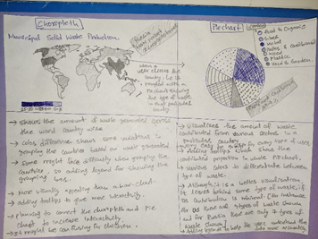

* Alternatives – Bar chart – was not used as it would be too cluttered, this could be mitigated by adding a way to select and filter different countries, but this would also add additional complexity in using the visualisation.
* Could combine pie chart and choropleth into a stacked bar chart, this would increase the data density of the visualisation, but this would come with the same drawbacks as the above solution.

## 4.2 Pie chart



* Alternatives – bar chart – as described above.
* Pie chart shows that the data is related, and each slice is part of the total MSW.

## 4.3 Scatter plot

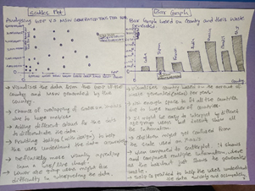

* Alternatives – bar chart – as described above.
* Scatter Plot compares the data with total MSW and GDP. It can easily fit all the counties data without any congestion. Although, the plots form a cluster, it can be dealt with adding zoom option in the visualisation.

# **4.Visualisation Design (Progress)**

## 4.1 Choropleth

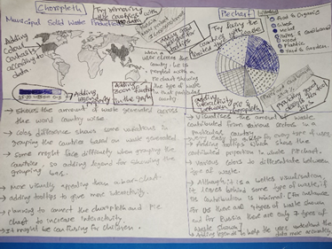

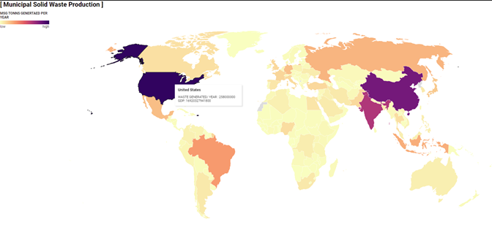

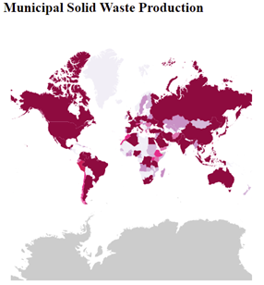

## 4.2 Pie Chart



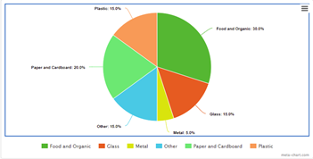

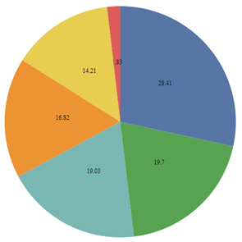

## 4.3 Scatter Plot

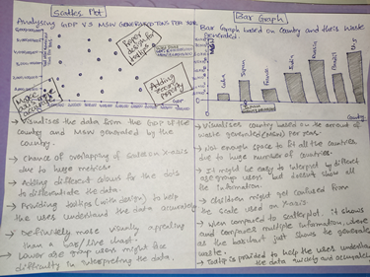

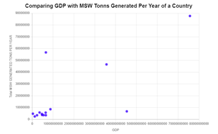

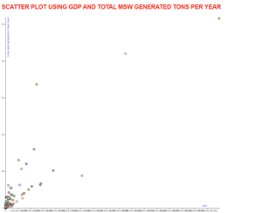

# **4.Visualisation Design (Final)**

## 4.1 Choropleth

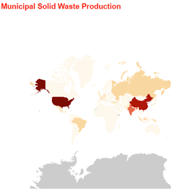

## 4.2 Pie Chart

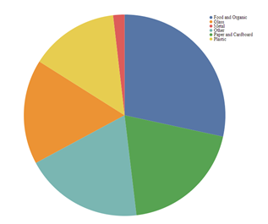

## 4.3 Scatter Plot

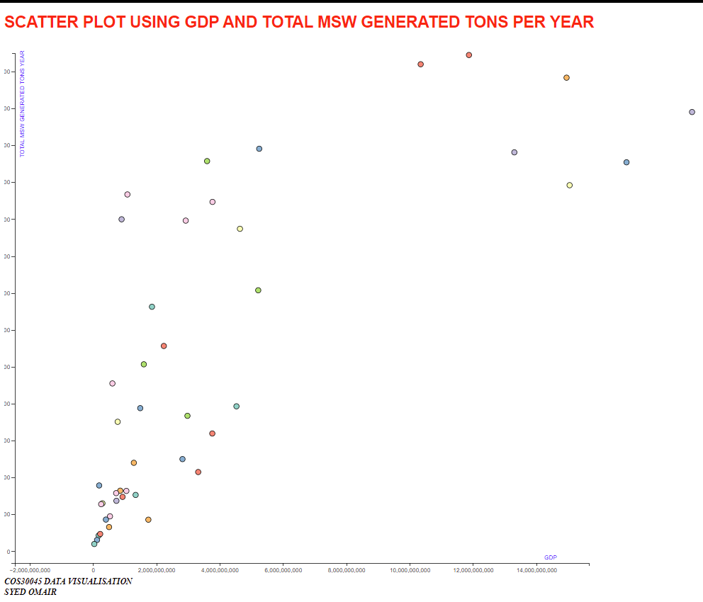

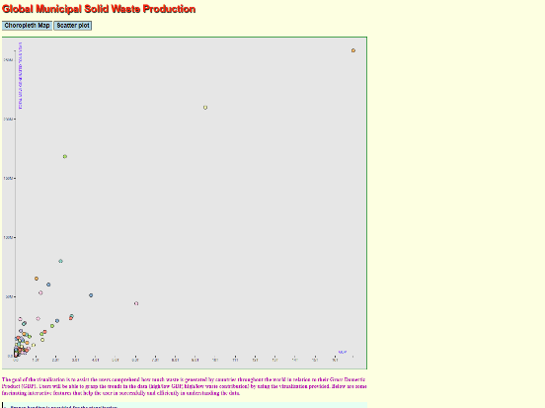 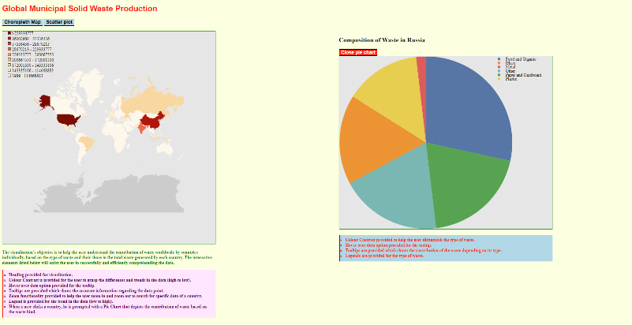

# **5.Validation**

## 5.1 Informed Consent

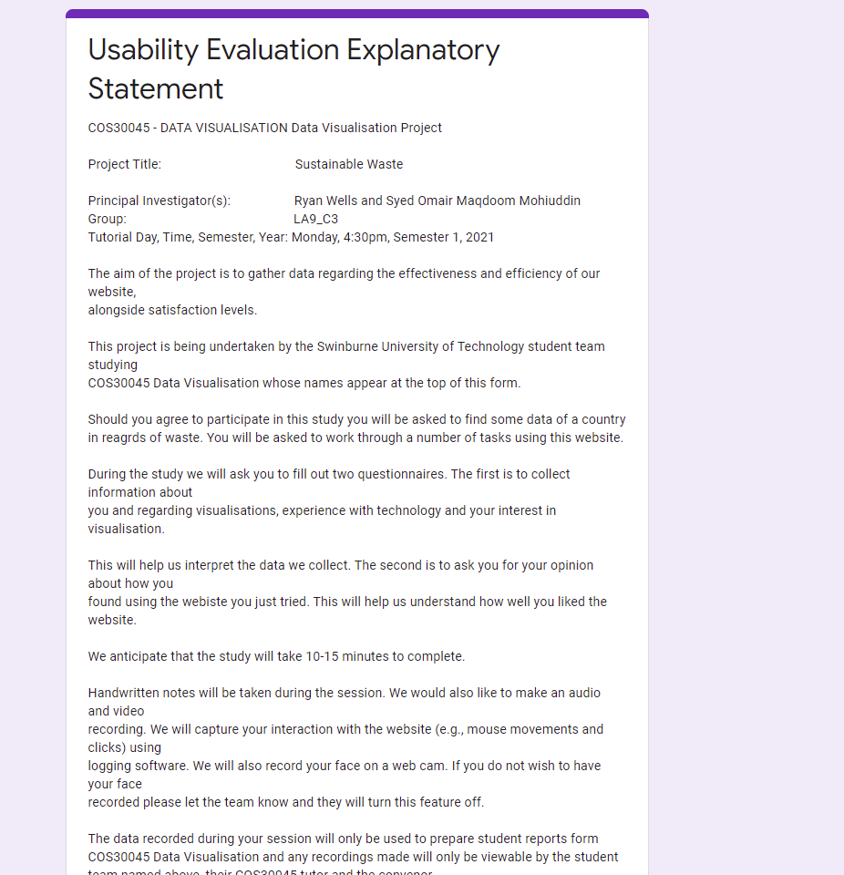

## 5.2 Pre-Study Questionnaire

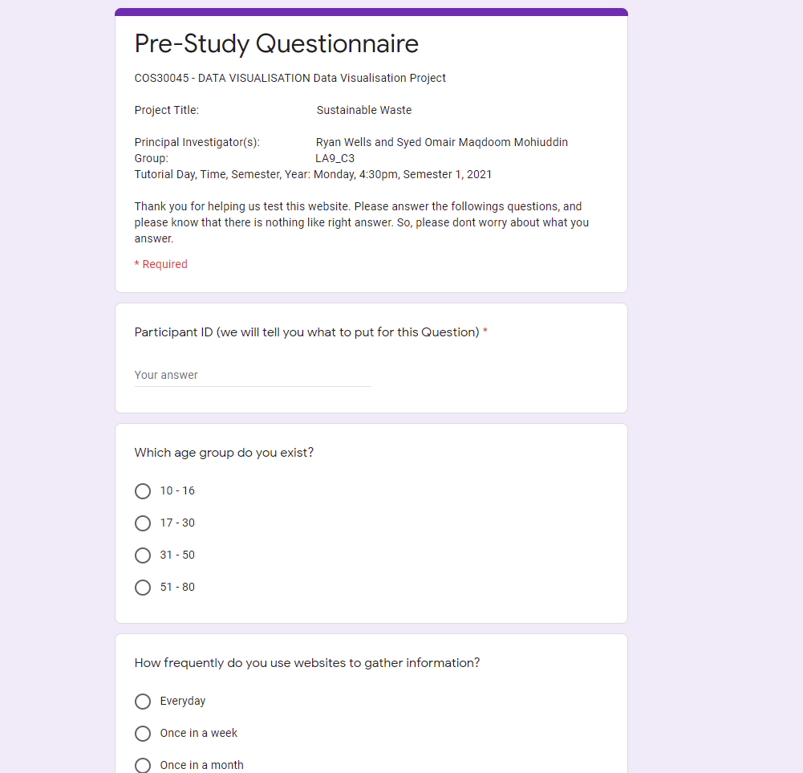

## 5.3 Evaluation Tasks

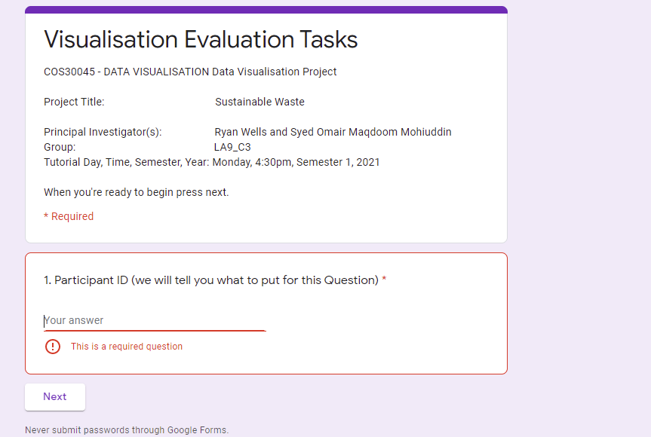 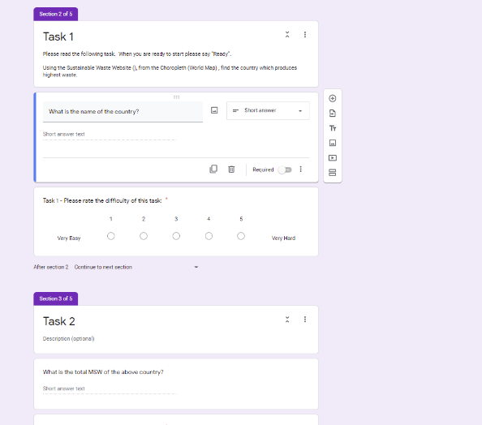

## 5.4 Post-Study Questionnaire – 1

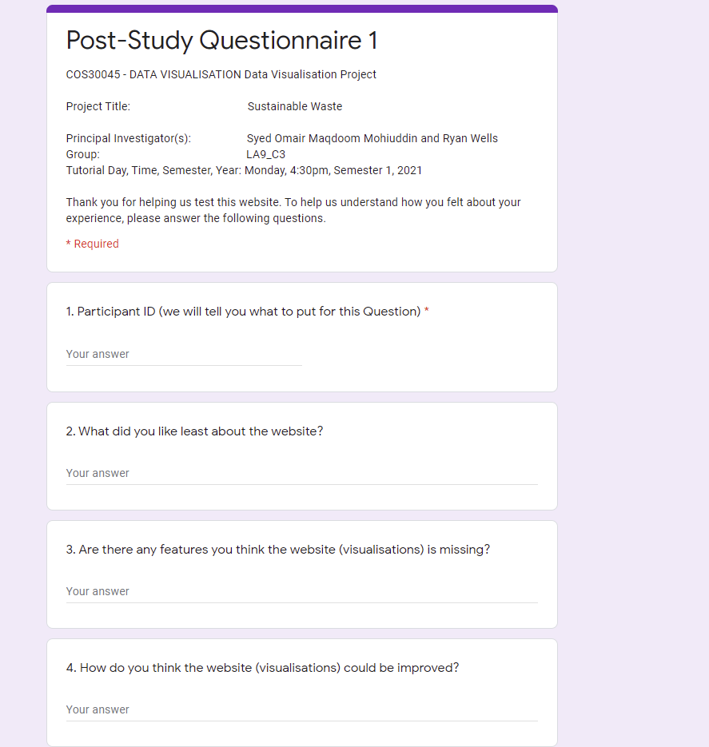

## 5.5 Post-Study Questionnaire – 2

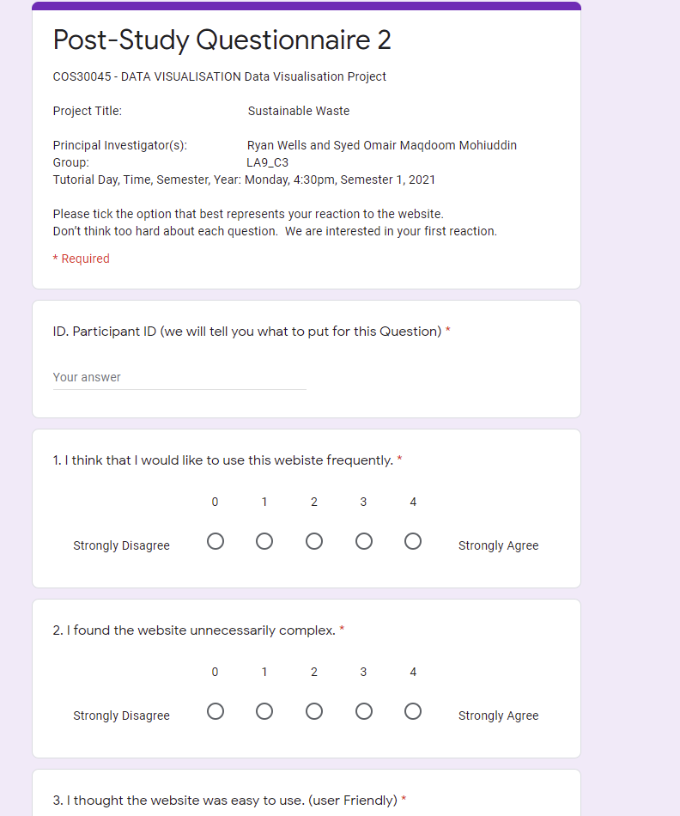

## 5.6 Responses and Results

## 5.7 Changes Required

# **6.Conclusion**

# **References**

Munzner, T 2014, Visualization Analysis and Design, CRC Press LLC, Florida. Available from: ProQuest Ebook Central. [20 May 2021].

Tufte, Edward R 1983, The visual display of quantitative information, Graphics Press, Cheshire. Available from: Swinburne Library.

The World Bank (2018). *What a Waste Global Database.* Retrieved from https://datacatalog.worldbank.org/dataset/what-waste-global-database